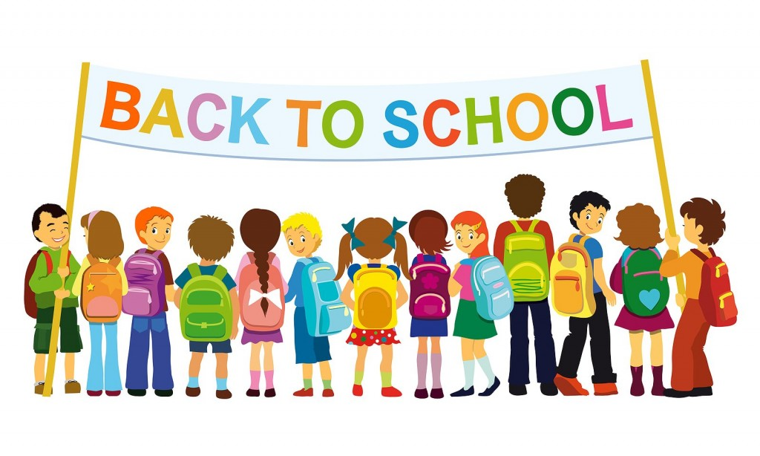

**Kindergarten Supply List**

* Backpack (large enough to hold a pocket folder)
* 1 small plastic **pencil box** **(8”by5”) no metal or zipped**
* Water bottle-24 oz-32 oz with pop up lid (helps reduce spills)

(We do not have drinking fountains in our room)

---**please label the above items only--**

* 2 pink erasers
* 10 fat glue sticks
* 2 boxes of 16 count crayons
* 1 box of 24 count crayons
* 4 pack of skinny dry erase markers-black
* 1 pair of **over** the ear child’s headphone
* 4 boxes of tissues
* 1 pair of safety scissors

Please make sure both your child’s BACKPACK and WATER BOTTLE have his/her name on it. Bring both items every day.

**The following classroom supplies would be greatly appreciated:**

bubbles, stickers, baby wipes, skittles, cheerios, hand sanitizer, 12 count-colored pencils, playdough, or gallon zip lock baggies